Tric

horizontal line

**Members:**

Abby Harris- Photographer/ Content Creator

Cam Bowen- Content Creator

Mary Clare Boyle- Coder

Dan Lawless- Coder

**Table of Contents:**

* ***Purpose of Site***
* ***Audience***
* ***Competitive Analysis***
* ***Preliminary Mockup and Architecture***
* ***Personas***
* ***Usability Testing***

**The main purpose of the site:**

The purpose of the site is to let people know about all of the different types of events that go on throughout the year. The site will have a calendar of events letting customers know what is going on each day so they can plan out their calendar for the year. The site will navigate you around the town of the concert venue. This gives you a chance to book a trip for the weekend and explore more things around the town. A lot of concert venue’s only offer events in the summer because the weather and the number of people who attend the events is much higher.

**Who visits our site?**

The main audience of the site is not just one general age range. The reason that the concert venue is all age ranges is because they have a variety of musicians who come and perform all different types of music. One weekend might have Kidz Bop band, another weekend have Dave Matthews Band, or Kanye West. One of the personas used for this site is the collaborator who reaches out to vendors to make sure everything is right. Another used is the dreamer who proceeds with a list of things to do constantly. The final persona is realist who wants things to get done.

**Competitive Analysis:**

Madison Square Garden

* Located in NYC, MSG is an extremely popular venue for concerts, sporting events, etc.
* The site included a calendar to view all the upcoming events and you can find links to buy tickets.
* It attracts several different kinds of people, of all ages. It depends on the event. MSG is unique in this list of three because it is the only venue that hosts sporting events.
* The front image shows the most current event and the background is of the venue itself. You can scroll left and right to see the other events going on and up and down to see more information about the venue.
* MSG has a Facebook, Twitter, Instagram, and Snapchat.

The Hollywood Bowl

* The Hollywood Bowl is one of the most popular concert venues in the country and the website is used for letting people know what events are being held.
* Their website has a hamburger menu which includes: concerts and events, plan your visit, about, learn, and support us tabs.
* The front page graphic changes every few seconds. One is a message to their donors, the nest is for the Los Angeles Philharmonic, and the last is a plan your visit link.
* The website includes several eye-catching photos to commit the user’s attention.
* Depending on the events, the Hollywood Bowl attends to a wide audience.
* The Hollywood Bowl is present on Facebook, Twitter, Instagram, and YouTube.

The Mann Center

* The Mann is a nonprofit performing arts venue. The website gives the user all the information you need about what is current and upcoming.
* There are links to information on seating charts, the food offered, planning a visit, etc. It also has a hamburger menu including: events, visit, support us, education, and rentals.
* The front page has the words "The Mann is" and then after every few seconds pops up a different answer with a video in the background for effect. It is very artistic and creative and there are several moving parts, which is eye catching.
* The Mann offers a membership and is attractive to a very wide audience of people.
* The Mann has a Facebook, Twitter, Instagram, Snapchat, YouTube, and Flickr.

**Preliminary Mockup and Architecture**

Home and Events Calendar

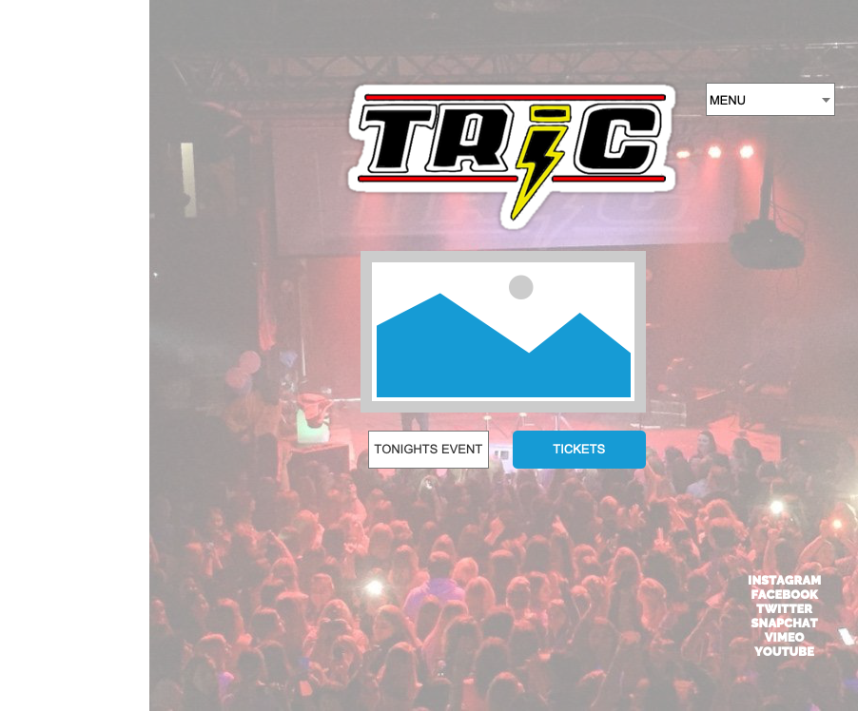

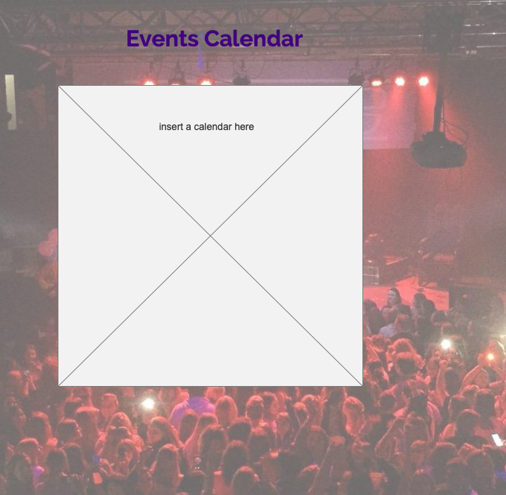

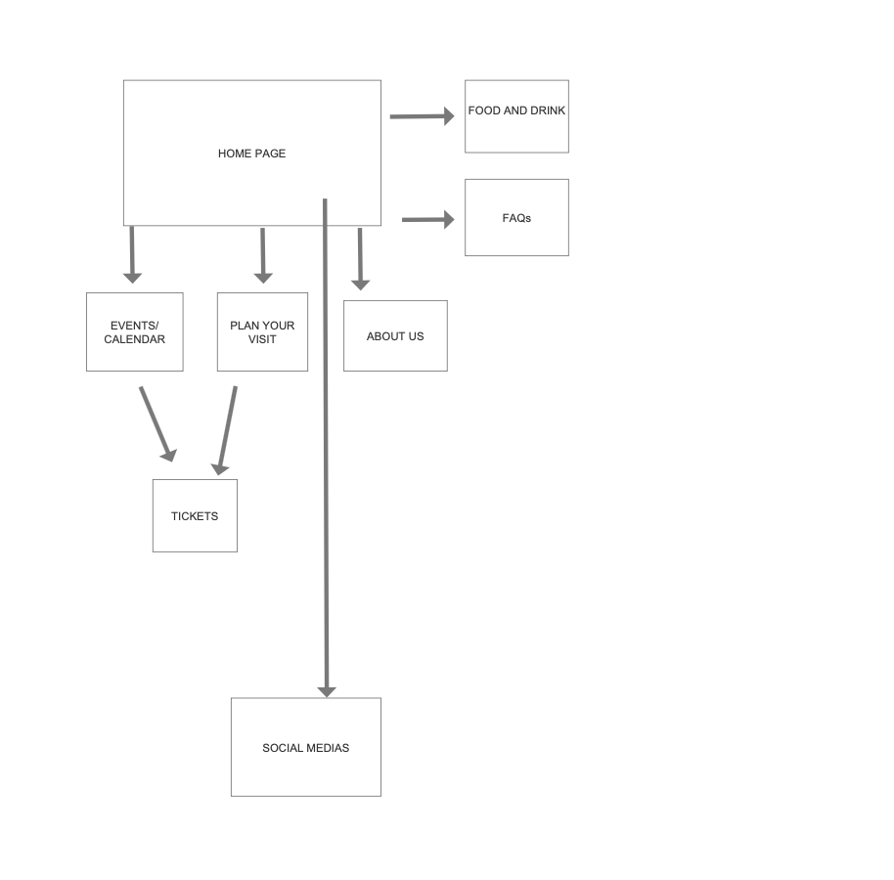

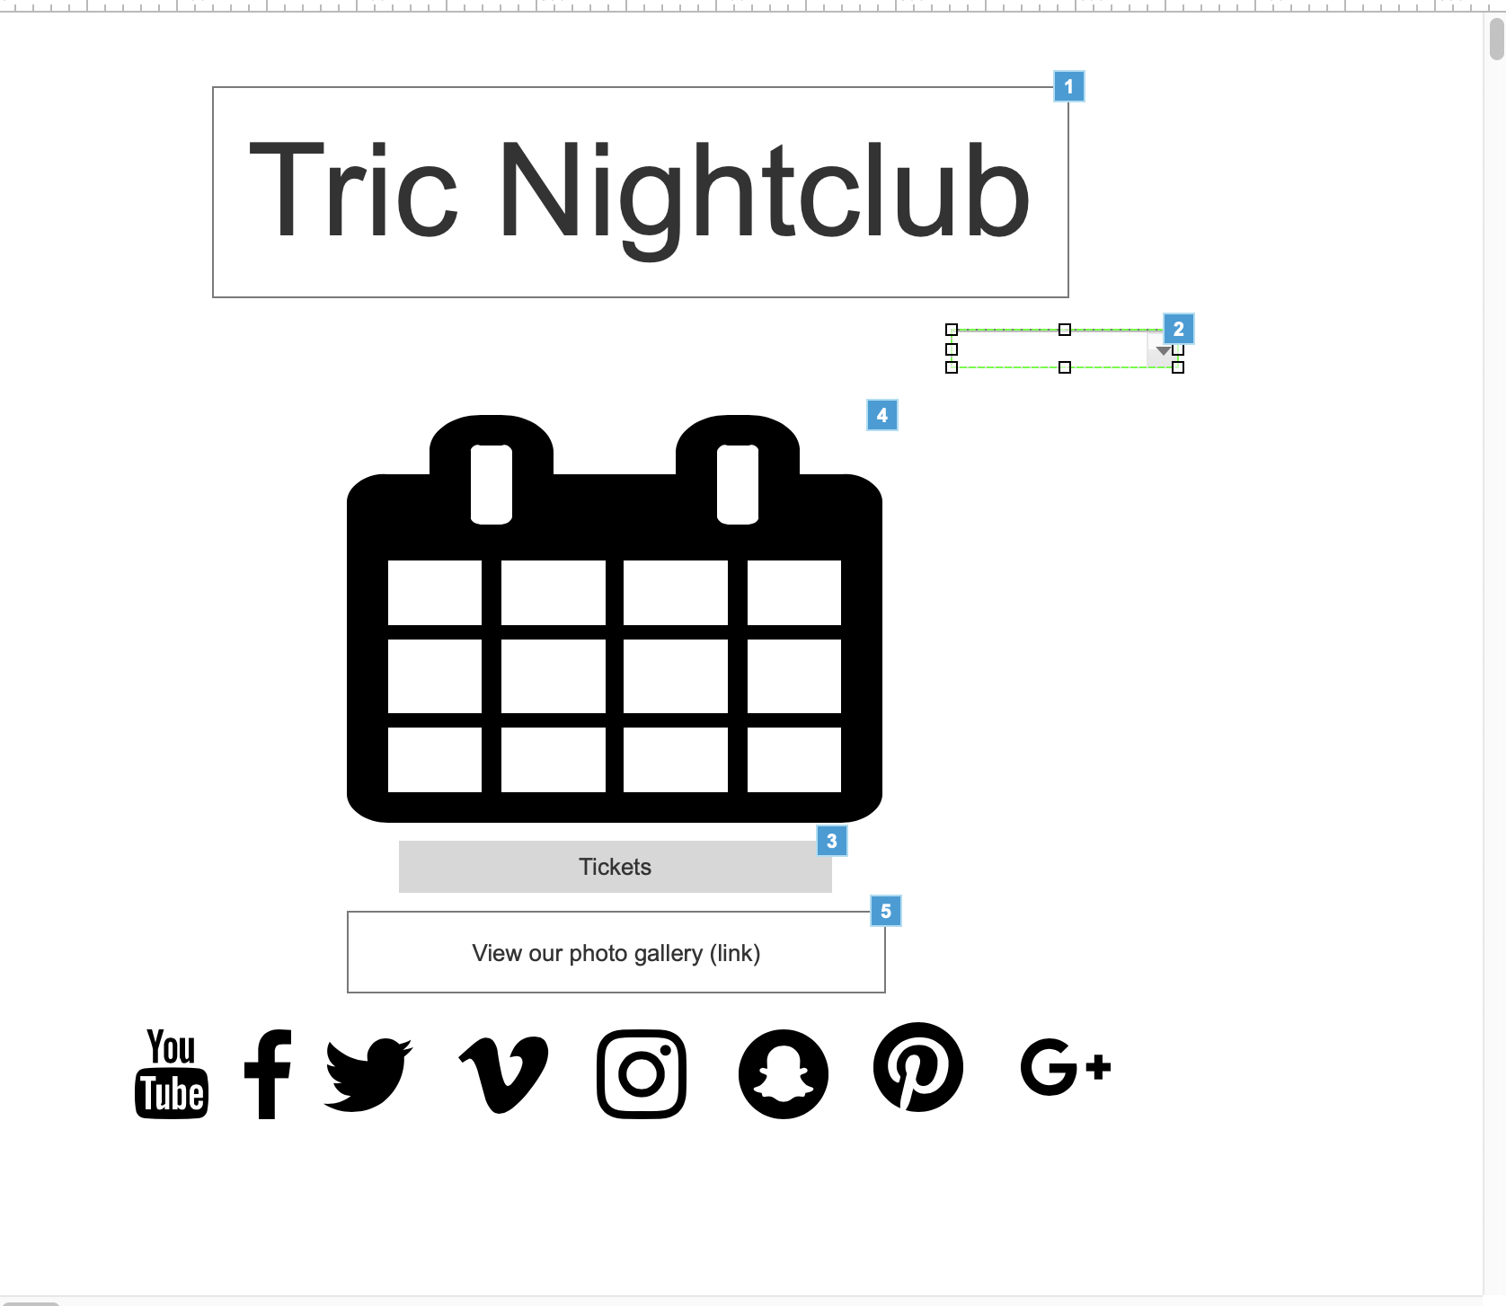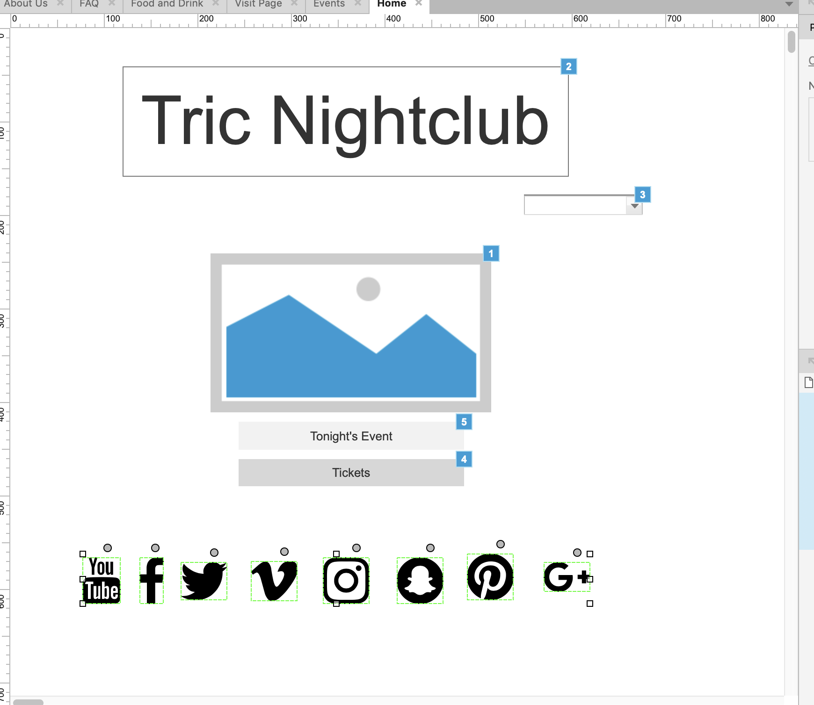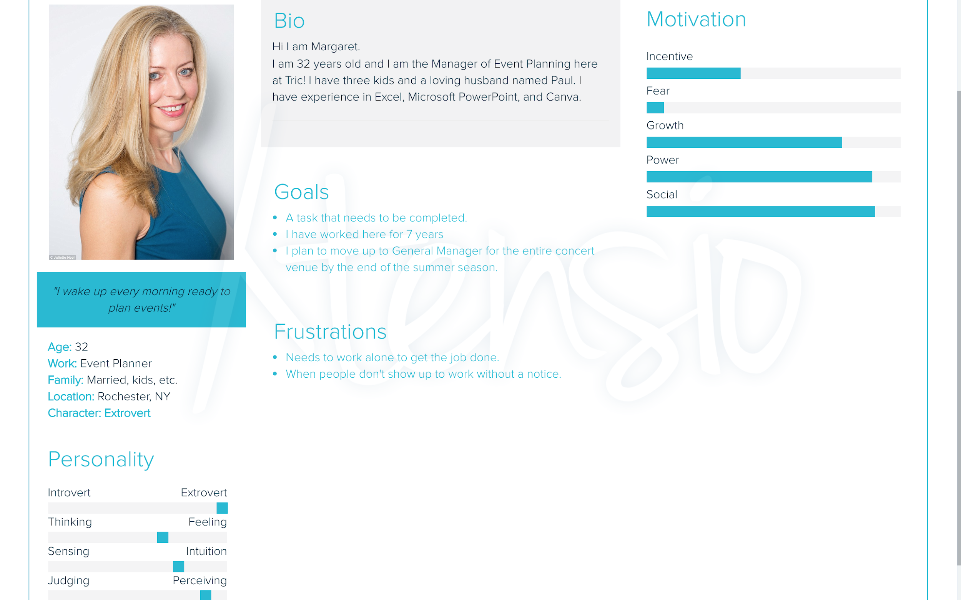



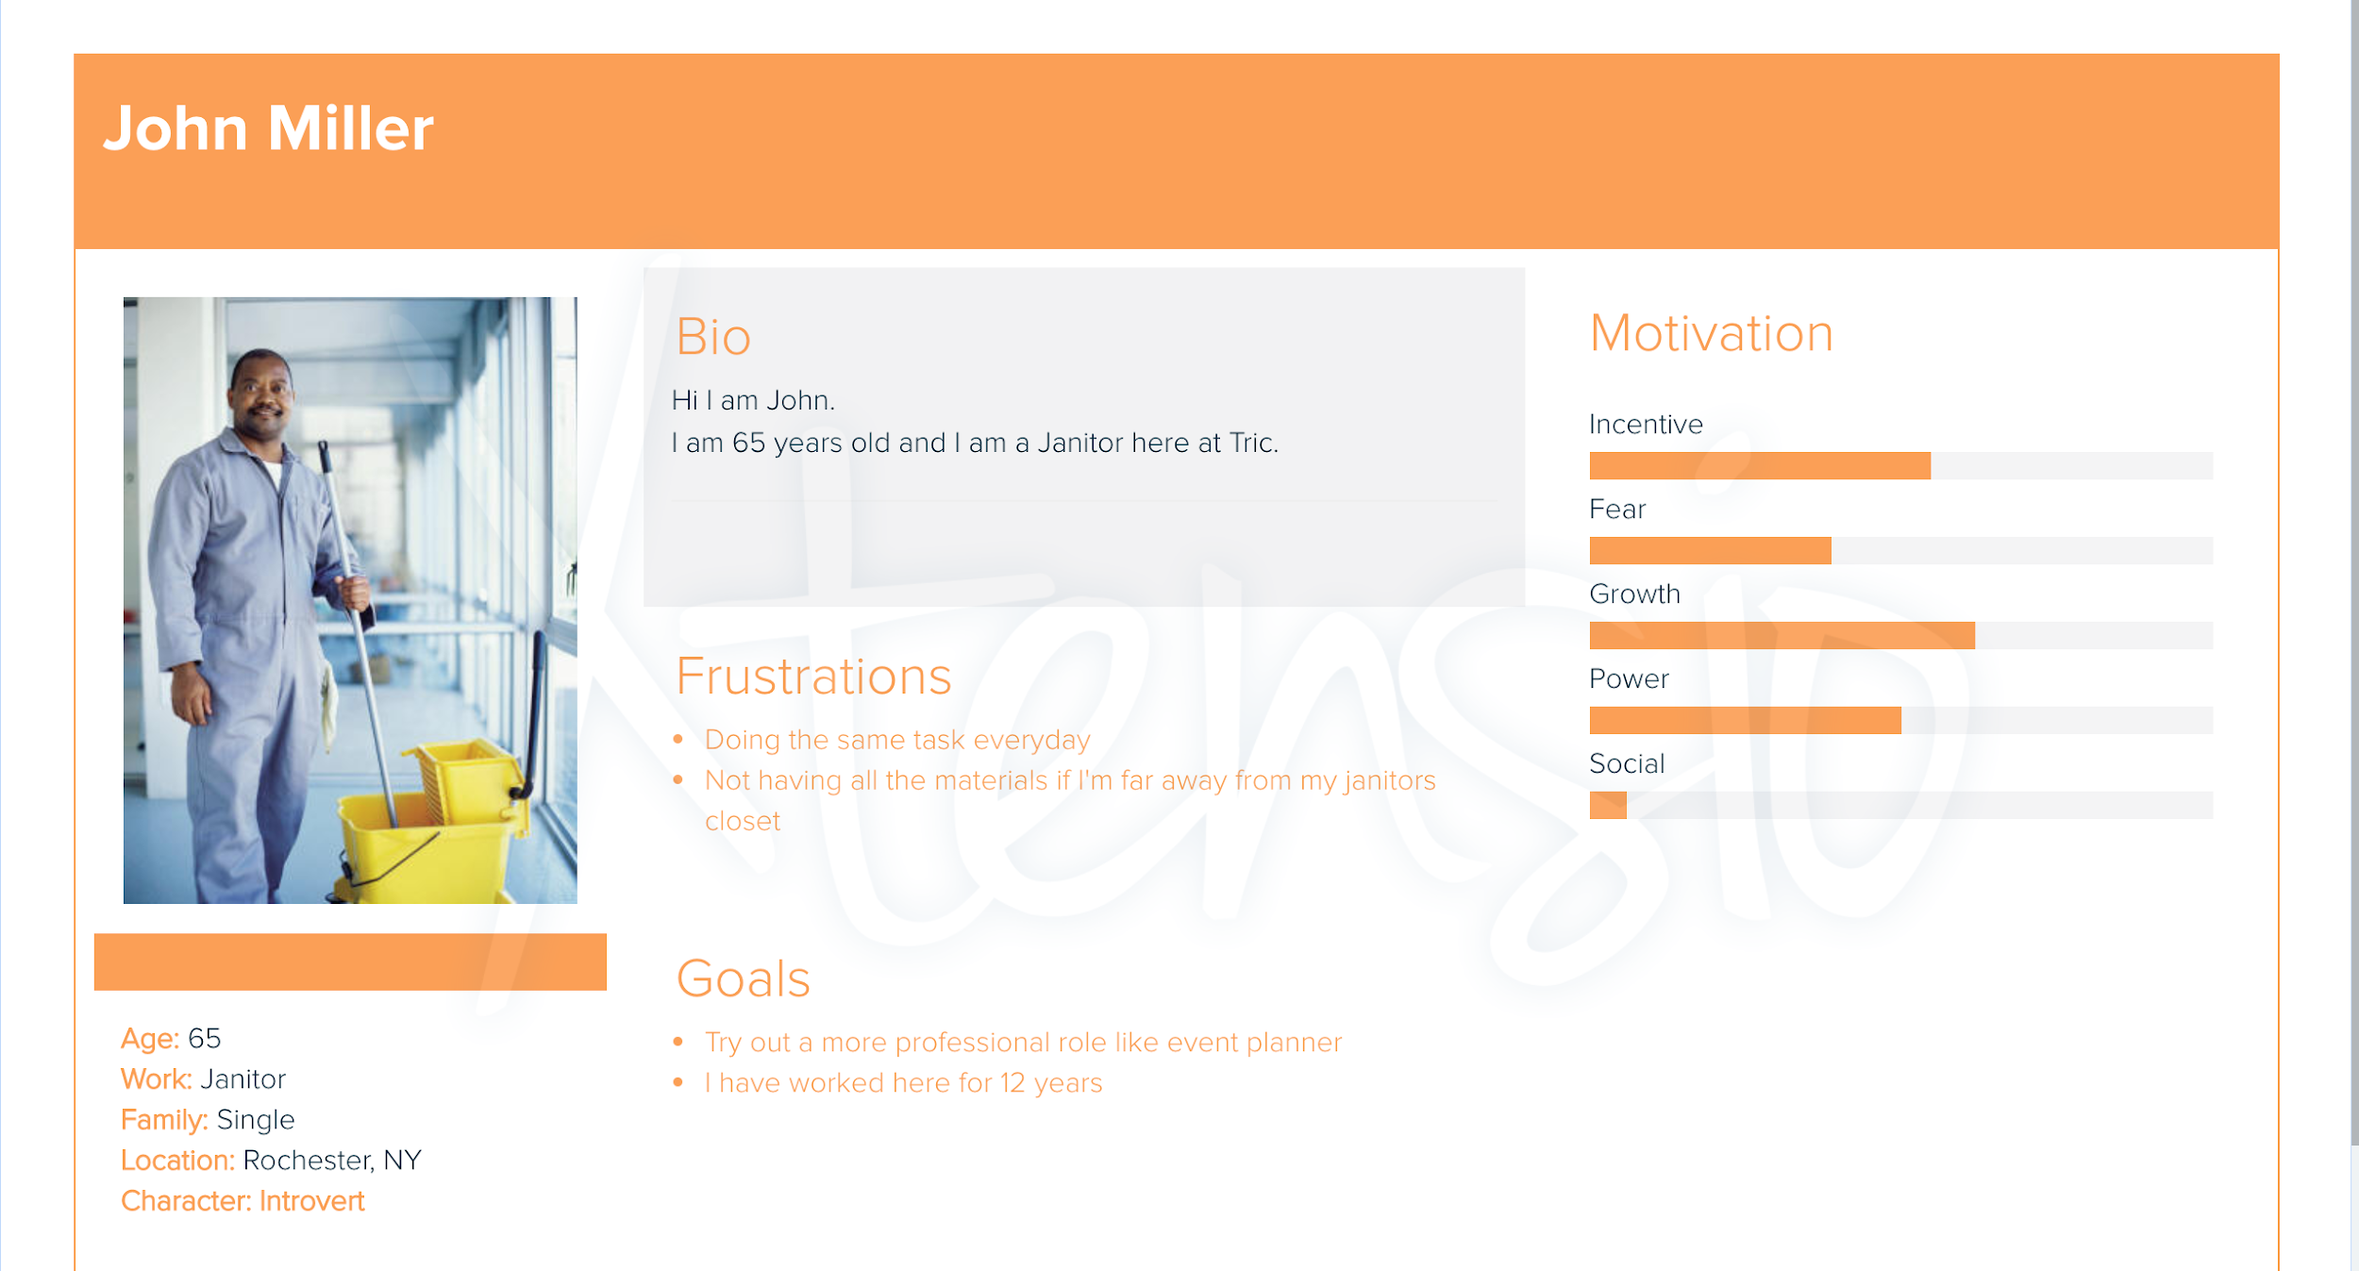

**Usability Testing:**

* For our usability testing, we had Mary Clare’s residents test our website. They navigated it well, saying it was fairly simple. Their criticism included a drop down menu or a hamburger menu. The site was basic and could have been more complex. In addition, a calendar and a video could add to the value.